Emerge2Wellness Support Services Participant Registration

Cultivating. Empowering. Equipping. (443) 242-4908

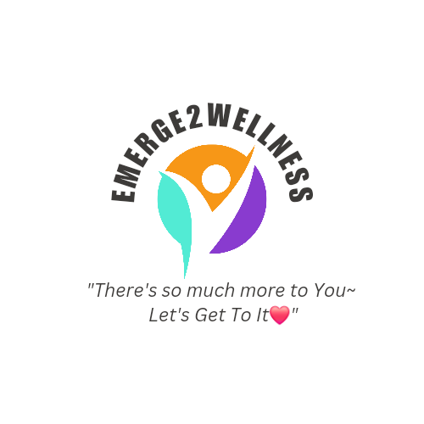

Today’s Date:_________________

Parent Info Self (19 & up):

Name: ______________________________ Phone#- ______________________

Email: _____________________________________________________

Attendee Information:

Name:_____________________________ Age: _______ Male Female D.O.B ____________

MEDICAID#-____________________________ Insurance Provider _______________________________

*SS# (last 4): ___________________

School Name: ______________________________  Grade: _____ Emergency Contact: _________________________

Relationship to Client: ______________________ Phone #: _________________________________

Physician/Therapist: ______________________________ Phone #: ____________________________

DIAGNOSIS: __________________________________ Diagnosis by: ____________________________

Phone: _________________________

Please state atleast 1 goal: ___________________________________________________________

Workshop(s) of Interest:_____________________________________________________________________________________

_______________________________________________________________________________________________________________

--------------------------------------------------------------------------------------------------------------------------------------------------------------------------------------------------

FOR OFFICE USE ONLY:

VERIFICATION OF MEDICAID STATUS:YES

NO DATE: LOCK-IN STATUS:

DATE CLIENT CONTACTED: BY WHOM:

(PLEASE EMAIL YOUR COMPLETED FORM TO EMPOWER@EMERG2WELLNESS.COM)